ASSIGNMENT 1

1) Code:

#include <stdio.h>

float result,exam_marks1,exam_marks2,sport_marks,activity1,activity2,activity3;

printf("enter 2 exam marks(out of 100)");

scanf(" %f%f",&exam_marks1,&exam_marks2);

printf("enter sport marks(out of 100)");

scanf(" %f",&sport_marks);

printf("enter the 3 activities marks(out of 100)");

scanf(" %f%f%f",&activity1,&activity2,&activity3);

result=((0.5*((exam_marks1+exam_marks2)/2))+(0.3*((activity3+activity2+activity1)/3))+(0.2*(sport_marks)));

printf("your net result is %.2f%%",result);

return 0;

}

Result: 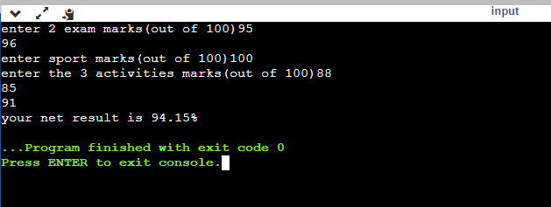

2) code:

#include <stdio.h>

int main() {

int integer;

printf("enter integer");

scanf(" %d",&integer);

printf("\n value in decimal is= %d",integer);

printf("\n value in hexadecimal is= %x",integer);

printf("\n value in octahedral is= %o",integer);

return 0;

}

Result:

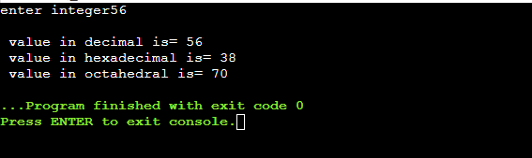

3)code:

#include <stdio.h>

int main() {

float decimal;

printf("enter decimal no.");

scanf(" %f",&decimal);

printf("\ndecimal till 2 places is= %.2f",decimal);

printf("\ndecimal till 2 places is= %.4f",decimal);

printf("\ndecimal till 2 places is= %.8f",decimal);

return 0;

}

Result:

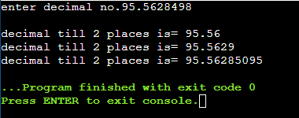

4)

Code:

#include <stdio.h>

int main() {

int sum=0;

for(int i=1;i<=200;i++)

{

if(i%2==0){

printf("%d\n",i);

sum=sum+i;

}

}

printf("sum of all even nos btw 1 to 200 is %d",sum);

return 0;

}

Result:

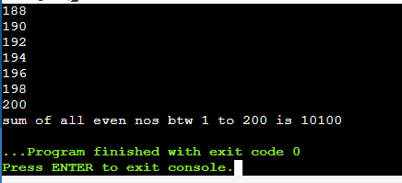

5)

Code:

#include <stdio.h>

int main() {

float n1,n2;

int sum;

printf("enter the numbers in decimal value");

scanf(" %f%f",&n1,&n2);

sum=n1+n2;

printf("number1 is %f\nnumber 2 is %f\n the integer value of their sum is %d",n1,n2,sum);

return 0;

}

Result:

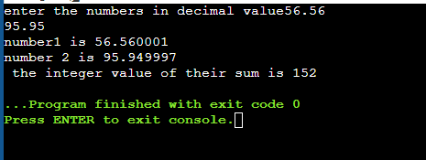

6)

Code:

#include <stdio.h>

int main() {

float n1;

int n2,tens;

printf("enter the number in decimal value");

scanf(" %f",&n1);

n2=n1;

tens=n2%10;

printf("rightmost digit of integer value of number is %d",tens);

return 0;

}

Result:

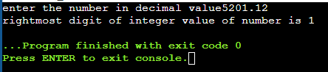

7)

Code:

#include<stdio.h>

void main(){ char item[100]; int q[100]; float p[100]; int n;

printf("Enter the number of items to be purchased\n");

scanf(" %d", &n);

printf("Enter the items in characters\n");

for(int i=0; i<n; i++) { scanf("%c", &item[i]);}

printf("Enter their respective quantities\n");

for(int i=0; i<n; i++) { scanf("%d", &q[i]);}

printf("Enter their corresponding prices\n");

for(int i=0; i<n; i++) { scanf("%f", &p[i]);}

printf("Item Quantity Price Amount\n");

for(int i=0; i<n; i++){ printf("%c %d %f %f\n", item[i], q[i], p[i], q[i]*p[i]);}}

Result:

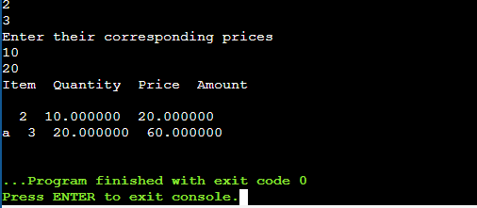

8)

Code:

#include <stdio.h>

#include<math.h>

int main() {

int n;

printf("enter no.");

scanf("%d",&n);

while(n%2==0)

{

n=n/2;

printf("%d\t",2);

}

for(int i=3;i<=sqrt(n);i=i+2)

{

if(n%i==0)

{

printf("%d\t",i);

n=n/i;

}

}

if(n>2)

printf("%d",n);

return 0;

}

Result:

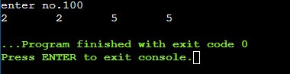

9)

Code:

#include <stdio.h>

#include<math.h>

int main() {

int n,original;

printf("enter no.");

scanf("%d",&n);

original=n;

while(n%2==0)

{

n=n/2;

if(n==1)

{break;

}

}

if(n==1)

printf("%d is power of 2",original);

else

printf("not power of 2");

return 0;

}

Result:

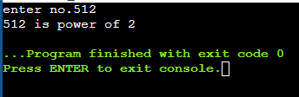

10)

Code:

#include <stdio.h>

#include<math.h>

int main() {

int n,k=1;

printf("enter number");

scanf("%d",&n);

for(int i=1;i<=n;i++)

{for(int j=1;j<=i;j++){

printf("%d",k++);}

printf("\n");}

return 0;

}

Result:

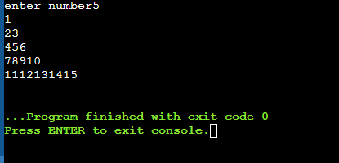

11)

Code:

#include <stdio.h>

int main()

{

int n1,n2;

printf("enter the numbers");

scanf("%d%d",&n1,&n2);

if(n1>n2)

{

if(n1%n2==0)

printf("multiple");

else

printf("not multiple");

}

else

{

if(n2%n1==0)

printf("multiple");

else

printf("not multiple");

}

return 0;

}

Result:

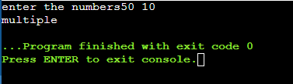

12)

Code:

#include <stdio.h>

int main()

{

float average;

int n1,n2,n3,max=0,min=0,total;

char choice;

printf("enter three numbers\n");

scanf(" %d%d%d",&n1,&n2,&n3);

printf("\npress a-average,g-greatest,s-smallest,t-total,d-display");

scanf(" %c",&choice);

switch(choice)

{

case 'a':average=(n1+n2+n3)/3.0;

printf("%f",average);

break;

case 'g':max=n1;

if(n2>max)

max=n2;

if(n3>max)

max=n3;

printf("%d",max);

break;

case 's':min=n1;

if(n2<min)

min=n2;

if(n3<min)

min=n3;

printf("%d",min);

break;

case 't':total=n1+n2+n3;

printf("%d",total);

break;

case 'd':printf("%d ,%d ,%d",n1,n2,n3);

break;

default: printf("invalid");

}

return 0;

}

Result:

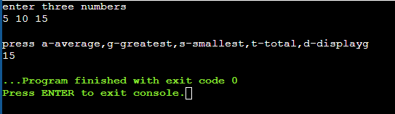

13)

Code:

#include <stdio.h>

double mysin(double x)

{

double value = x;

double sum = x;

int neg_pos = 1;

int fac = 1;

int counter = 0;

while(1)

{

neg_pos *= -1;

fac += 2;

value = value/(fac*(fac-1));

value = value*x*x*neg_pos;

sum += value;

counter++;

if (counter == 100) break;

}

return sum;

}

int main()

{

double number;

scanf("%lf",&number);

printf("%g",mysin(number));

//printf("%g",number);

}

Result:

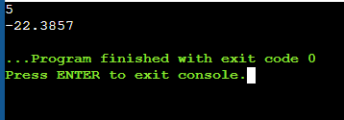

14)

Code:

#include <stdio.h>

int main()

{

float cost;

float units;

printf("enter units of electricity consumed");

scanf("%f",&units);

if(units>=0&&units<=150)

{

cost=units*3;

printf("total bill is %f",cost);

}

else if(units>150&&units<=350)

{

cost=100+(units-150)*3.75;

printf("total bill is %f",cost);

}

else if(units>351&&units<=450)

{

cost=250+(units-350)*4;

printf("total bill is %f",cost);

}

else if(units>451&&units<=600)

{

cost=300+(units-450)*4.25;

printf("total bill is %f",cost);

}

else if (units>600)

{

cost=400+(units-600)*5;

printf("total bill is %f",cost);

}

else

printf("invalid input");

return 0;

}

Result:

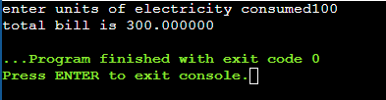

15)

Code:

#include <stdio.h>

int main()

{

float degree;

printf("enter angle in degree");

scanf("%f",&degree);

for(int i=0;i<=100;i++)

{

if(degree>(360*i)&&degree<(2*i+90))

{printf("1ST quadrant");

break;}

else if(degree>(2*i+90)&&degree<(360*i+180))

{printf("2ND quadrant");

break;}

else if(degree>(360*i+180)&&degree<(360*i+270))

{printf("3RD quadrant");

break;}

else if(degree>(360*i+270)&&degree<(360*(i+1)))

{printf("4TH quadrant");

break;}

else if(degree==360*i||degree==360*i+180)

{printf("x axis");

break;}

else if(degree==2*i+90||degree==360*i+270)

{

printf("y axis");

break;

}

}

return 0;

}

Result:

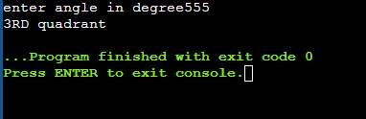

16)

Code:

#include<stdio.h>

#include<stdlib.h>

int main(){

int dob_date[10],dob_month[10],dob_year[10],date,month,year,c_date,c_month,c_year;

char choice;

printf("\nenter todays date(dd/mm/yy)");

scanf(" %d%d%d",&date,&month,&year);

for(int i=0;i<10;i++)

{

printf("\nenter date of birth(dd/mm/yy)");

scanf(" %d%d%d",&dob_date[i],&dob_month[i],&dob_year[i]);

c_date=abs(date-dob_date[i]);

c_month=abs(month-dob_month[i]);

c_year=abs(year-dob_year[i]);

printf("\nperson is %d years %d months and %d days old \ni.e his age is %d/%d/%d",c_year,c_month,c_date,c_date,c_month,c_year);

printf("\ndo you want to find age of another person? \npress 'c' for continue else press 'e' for exit");

scanf(" %c",&choice);

if(choice=='c')

continue;

else

break;

}

return 0;

}

Result:

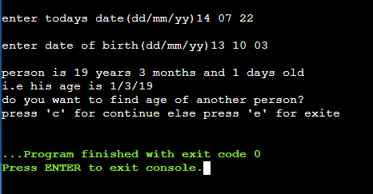

17)

Code:

#include <stdio.h>

int main()

{

int s1[50],s2[50],s3[50],t[50],class_sum=0;

float class_avg;

for(int i=0;i<=50;i++)

{

printf("\nenter student%d marks in all three subjects",i+1);

scanf("%d%d%d",&s1[i],&s2[i],&s3[i]);

t[i]=s1[i]+s2[i]+s3[i];

printf("\nhis total marks is %d",t[i]);

printf("\nhis average marks is %f\n",(t[i]/3.0));

}

for(int i=0;i<50;i++){

class_sum=class_sum+t[i];}

printf("\n%d",class_sum);

class_avg=class_sum/50;

printf("\n%f",class_avg);

}

Result:

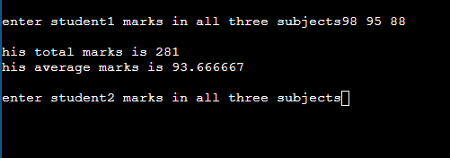

18)

Code:

#include<stdio.h>

void main(){ for(int i=0; i<=4;){

printf("Iteration %d\n", i);

i+=1;}}

Result:

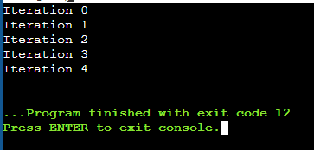

19)

i)Code:

#include <stdio.h>

void main() {

int num = 1;

printf("\n Example of BREAK Statement using WHILE Loop\n");

printf("First 15 natural numbers are: \n");

while (1){

printf("%d ", num++);

if (num == 16)

break;

}

printf("\n value of last number after 15 is %d", num);

}

Result:

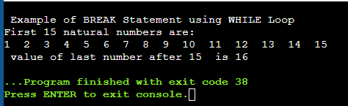

ii) code:

#include <stdio.h>

void main() {

int num;

printf("\nExample of CONTINUE Statement using FOR Loop\n");

for (num = 1; num<5 ; num++){

printf("\n\nThis is %d iteration", num);

if (num == 3)

continue;

printf("\n%d",num); // this statement will not be displayed for 3rd iteration

}

}

result:

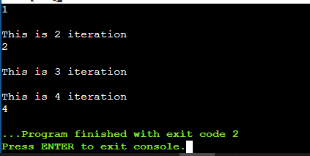

iii) code:

#include <stdio.h>

void main() {

int num1, num2;

printf("enter 2 numbers");

scanf("%d%d",&num1,&num2);

if (num1 == 0)

goto error_num1_zero;// jumps to the label error_num1_zero

if (num2 == 0)

goto error_num2_zero;// jumps to the label error_num2_zero

// below two lines will be executed if both the numbers are non-zero, else it will continue executing any one of the label

int result = num1 / num2;

printf("Result is %d", result);

goto end;

error_num2_zero:printf("\nResults in Division by zero! i.e infininty");

goto end;

error_num1_zero: printf("\nFirst number is zero and hence result will be zero");

end:

printf("\nEnd of the program!");

}

result:

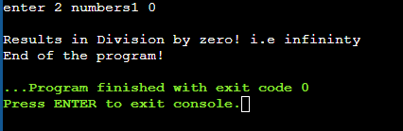

20)

Code:

#include <stdio.h>

void main() {

for(int i=1;i<=100;i++)

{

if(i%2!=0&&i%3!=0)

{

printf("%d\n",i);

}

}

}

Result:

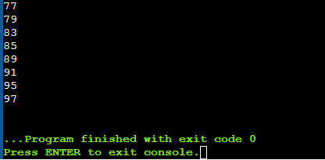

21)

Code:

#include <stdio.h>

void main() {

char vehicle;

float hours;

float charge;

printf("enter the type of vehicle(c for car,b for bus/truck,2 for 2 wheeler");

scanf("%c",&vehicle);

switch(vehicle)

{

case 'b': printf("enter no. of hours you wish to park");

scanf("%f",&hours);

charge=hours*20;

printf("charge= Rs %.2f",charge);

break;

case 'c': printf("enter no. of hours you wish to park");

scanf("%f",&hours);

charge=hours*10;

printf("charge= Rs %.2f",charge);

break;

case '2': printf("enter no. of hours you wish to park");

scanf("%f",&hours);

charge=hours*5;

printf("charge= Rs %.2f",charge);

break;

default:printf("enter valid input");

}

}

Result:

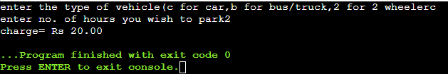

22)

Code:

#include <stdio.h>

int main()

{

for(int i=0;i<5;i++)

{

for(int j=0;j<=i;j++)

printf("*");

printf("\n");}

}

Result:

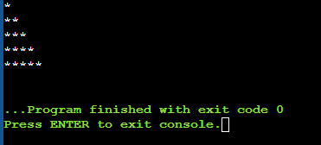

23)

Code:

#include <stdio.h>

int main()

{

for(int i=1;i<=5;i++)

{

for(int j=1;j<=i;j++)

printf("%d",i);

printf("\n");}

}

Result:

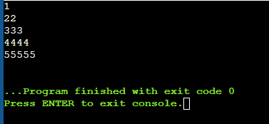

24)

Code:

#include<stdio.h>

void main(){ int i=1; int N;

scanf("%d", &N);

while(i<=N) { int j=1;

int k=1;

while(k<=N) { if (k<=N-i) { printf(" ");}

else if (k>N-i) { printf("%d", j); j+=1;}

k=k+1;}

j= i-1;

int z=1;

while(z<=i-1) { printf("%d", j); j-=1;

z=z+1;}

printf("\n");

i=i+1;}}

Result:

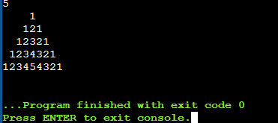

25)

Code:

#include <stdio.h>

void main() {

float invest,rate=0.05,interest;

int t;

printf("enter amount to invest");

scanf("%f",&invest);

printf("given rate of interest is 5%%");

printf("\n enter the time period for which you want to invest");

scanf("%d",&t);

for(int i=1;i<=t;i++)

{

interest=invest*i*0.05;

invest=invest+interest;

printf("\namount after %d year = %f",i,invest);

}

}

Result:

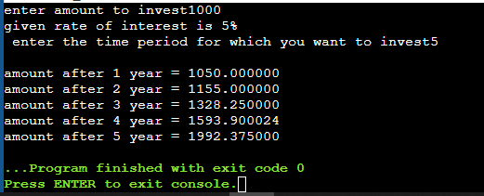

26)

Code:

#include <stdio.h>

void main() {

float a,b,c,d,e,f,g;

a=18-12/3+3*5-1;

b=18-12/(3+3)*(5-1);

c=6-7/3+8*2-1;

d=6-7/(3+8)*(2-1);

e=6-(7/(3+8)*2)-1;

f=6- 6/(3+ 9)*(2-1);

g=10+2*((19%5)*(4+(6-3)/(10+2)));

printf("\na)%.2f",a);

printf("\nb)%.2f",b);

printf("\nc)%.2f",c);

printf("\nd)%.2f",d);

printf("\ne)%.2f",e);

printf("\nf)%.2f",f);

printf("\ng)%.2f",g);

}

Result:

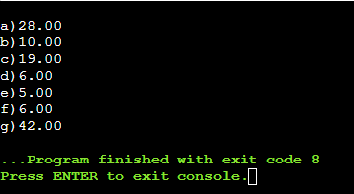

27)

I)Code:

#include<stdio.h>

void main(){ int N; int i, rem; int count=0, sum=0;

printf("Enter the number\n");

scanf("%d", &N);

i=N;

while(i>=10){ count+=1;

rem=i%10;

sum+=rem;

i/=10;}

count++;

sum+=i;

printf("Sum of all digits=%d\n Number of digits of the number=%d\n", sum, count);

}

ii)

code:

#include<stdio.h>

void main(){ int N; int divided=0;

int i=2;

printf("Enter the number\n");

scanf("%d", &N);

while(i<=N-1){ if (N%i==0){ divided=1; break;}

i+=1;}

if(!divided) printf("Prime Number\n");

else printf("Not Prime\n");}

28)

Code:

#include <stdio.h>

void main() {

float average;

int n,min,total=0,sum=0,positive=0,negative=0;

printf("enter the length of array");

scanf("%d",&n);

printf("enter elements of array");

int ar[n];

for(int i=0;i<n;i++)

{

scanf("%d",&ar[i]);

}

for(int i=0;i<n;i++)

{

total=total+ar[i];

if(ar[i]>0)

{

sum=sum+ar[i];

positive++;

}

else if(ar[i]<0)

{

negative++;

}

}

min=ar[0];

for(int i=0;i<n;i++)

{

if(ar[i]<min)

min=ar[i];

}

average=total/n;

printf("\npositive numbers=%d",positive);

printf("\nnegative numbers=%d",negative);

printf("\nsum of positive numbers=%d",sum);

printf("\n average=%.2f",average);

printf("\nsmallest number=%d",min);

}

Result:

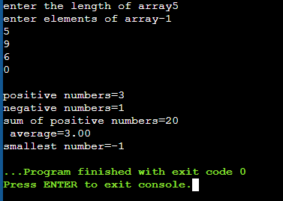

29)

Code:

#include <stdio.h>

void main() {

int n,max,max2;

printf("enter the length of array");

scanf("%d",&n);

printf("enter elements of array");

int ar[n],arr[n];

for(int i=0;i<n;i++)

{

scanf("%d",&ar[i]);

}

max=ar[0];

for(int i=0;i<n;i++)

{if (ar[i]>max)

max=ar[i];

}

for(int i=0;i<n;i++){

if(ar[i]!=max)

arr[i]=ar[i];

else

arr[i]=0;

}

max2=arr[0];

for(int i=0;i<n;i++)

{if (arr[i]>max2)

max2=arr[i];}

printf("second max number is %d",max2);

}

Result:

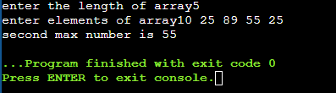

30)

Code:

#include<stdio.h>

#include<math.h>

void main()

{

char ch;

float a,b;

printf("Enter the two numbers\n");

scanf(" %f%f", &a, &b);

printf("enter + for Addition\n - for Subtraction\n * for Multiplication\n / for division\n %% for remainder\n ^ for finding Power\n ~ for Square root of a number\n");

scanf(" %c",&ch);

if(a>b){

switch(ch) {

case '+': printf("%f", a+b);

break;

case '-': printf("%f", a-b);

break;

case '*': printf("%f", a*b);

break;

case '/': printf("%f", a/b);

break;

case '%': printf("%d", (int)a%(int)b);

break;

case '^': printf("%f", pow(a,b));

break;

case '~': printf("%f", sqrt(a));

break;

default: printf("Invalid input\n");}}

else if(b>a){

switch(ch) {

case '+': printf("%f", a+b);

break;

case '-': printf("%f", a-b);

break;

case '*': printf("%f", a*b);

break;

case '/': printf("%f", b/a);

break;

case '%': printf("%d", (int)b%(int)a);

break;

case '^': printf("%f", pow(b,a));

break;

case '~': printf("%f", sqrt(b));

break;

default: printf("Invalid input\n");

}

}}

Result:

